WARNING: Covid-19 Vaccine Mandate for (Fill in Organization/Group/students/residents, i.e. San Diego Employees) is a Felony under Title 18 USC §241 and §242

This WARNING is sent to the attention of “list names of council members, school board members or other public officials who passed and/or enforced a mandate” who are hereafter referred to collectively as the ‘SUSPECTS.’

Per (cite a meeting data, and name of the meeting, i.e. November 29, 2021 San Diego Council Special Meeting) the SUSPECTS proposed and passed “Name the mandate – i.e. AN EMERGENCY ORIDINANCE OF THE COUNCIL OF THE CITY OF SAN DIEGO PURSUANT TO CHARTER SECTION 295, ADOPTING A MANDATORY COVID-19 VACCINATION POLICY’ hereafter referred to as the ‘COVID-19 VACCINE MANDATE’.

Before addressing the grossly unlawful overreach and criminality of the SUSPECTS in passing the COVID-19 VACCINE MANDATE, it is imperative to address the major contributing reasons why the SUSPECTS as well as numerous other local and national organizations and government officials are under the delusion that they have the right to yield unbridled tyrannical authority in mandating unhealthy, damaging, and sometimes deadly mandates, such as the COVID-19 VACCINE MANDATE. The SUSPECTS may believe they have complete immunity against willful misconduct because of the ‘immunity clause’ under the PREP ACT, per the EUA guidance issued by the Department of Health and Human Services (HHS).¹

Per the PREP Act; Willful misconduct is misconduct that is greater than any form of recklessness or negligence. It is defined in the PREP Act as an act or failure to act that is taken: intentionally to achieve a wrongful purpose; knowingly without legal or factual justification; and in disregard of a known or obvious risk that is so great as to make it highly probable that the harm will outweigh the benefit. All three of these conditions must be proven with clear and convincing evidence.¹

Willful misconduct cannot be found against: A program planner or qualified person who acts in accordance with applicable directions, guidelines, or recommendations issued by the HHS regarding administration and use of a countermeasure as long as HHS or the State or local health authority is notified about the serious injury or death within seven days of its discovery.¹

Under EUA guidance from HHS, as well as federal, state, and local officials, the SUSPECTS are conspiring to coerce (name group of citizens, ie. city employees) to be injected with an experimental biological agent that can result in physical harm and even death of citizens. Following HHS EUA guidance for a medical countermeasure does NOT provide immunity to the SUSPECTS from civil or criminal charges in passing the COVID-19 VACCINE MANDATE.

Per 18 USC §241 and §242, the SUSPECTS do NOT have criminal immunity for depriving (name citizens, i.e. San Diego employees) of constitutional rights in passing the COVID-19 VACCINE MANDATE, nor is there immunity for the SUSPETCS if (name citizens – i.e. San Diego employees) suffer bodily injuries, permanent disabilities, or death from the experimental COVID-19 biological agents, aka COVID-19 vaccines, due to the COVID-19 VACCINE MANDATE.

To ensure the SUSPECTS do not have plausible deniability of a lack of knowledge that the COVID-19 VACCINE MANDATE can result in the permanent disabilities, infliction of chronic diseases, and/or death of (name group of citizens – i.e. San Diego employees) the following information is provided.
Per the FDA’s own October 22, 2020, COVID-19 Monitoring Vaccine Safety & Efficacy Presentation, the FDA states anticipated serious adverse events that can result in permanent injuries, autoimmune diseases, chronic diseases, disabilities, and death from the COVID19 vaccines.²
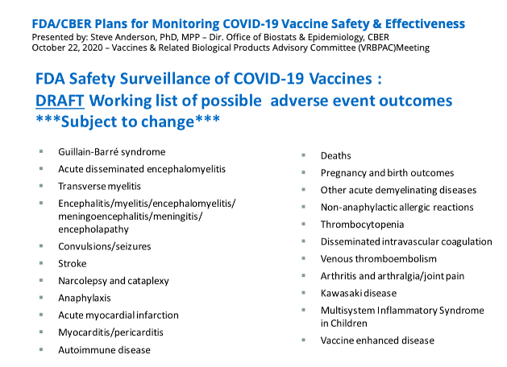

The COVID-19 Vaccines serious adverse events identified by the FDA in October of 2020 have also been reported in VAERS, including DEATH. As of December 3, 2021, there have been 946,461 adverse event reports from the COVID-19 vaccines, including almost 20,000 deaths, over 100,000 hospitalizations, and over 32,000 permanent disabilities.³

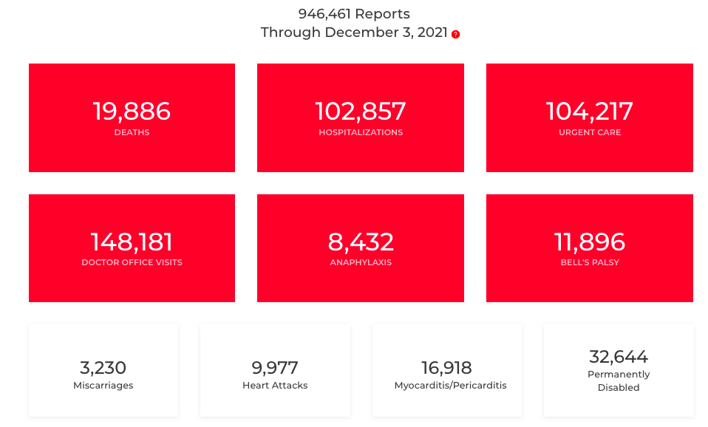

According to a 3-year Harvard Study, “…fewer than 1% of vaccine adverse events are reported (in VAERS),” ⁴

The SUSPECTS’ claim that the COVID-19 VACCINE MANDATE is for public safety is disingenuous and reckless. There are no statistically clinically significant data to substantiate the public safety claim for such a mandate.

The COVID-19 vaccines do not prevent infections or hospitalization. Per page 25 of Pfizer’s Biological License Application (BLA), approved on August 23, 2021 (per the FDA approval letter), the Pharmacovigilance Plan clearly states that Vaccine Efficacy is MISSING INFORMATION.⁵

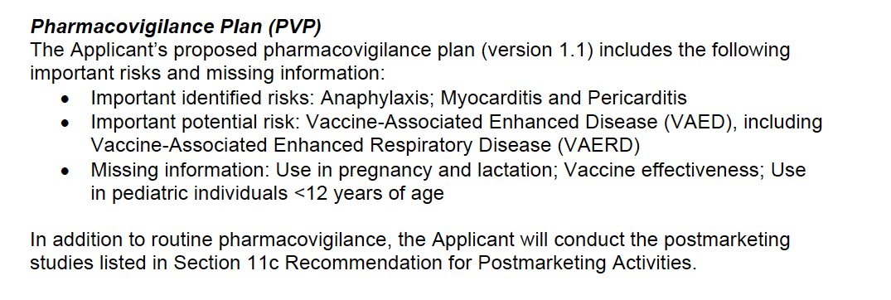

The Pfizer COMIRNATY FDA license application also clearly states:⁵
- COMIRNATY is known to cause heart inflammation (myocarditis and pericarditis).
- COMIRNATY correlates with vaccine-associated enhanced disease and vaccine enhanced respiratory disease.

Any statements made by medical doctors or other healthcare experts claiming that the majority of incidences of heart inflammation are mild and go away in a couple days without any sequalae (clinical consequences) are reckless statements. The COMIRNATY FDA license application goes on to list six (6) heart inflammation studies that need to be completed to understand the full risks of injury, morbidity and death of the heart inflammation caused by Pfizer’s COVID-19 vaccines. As the FDA and Pfizer will not understand the consequences of myocarditis/pericarditis from the COVID-19 vaccines for at least another 5 years, it is disingenuous for a local or national medical expert to claim they know this information.

The COVID-19 vaccines can and have resulted in the injury, hospitalizations, disabilities, and deaths of American citizens and children. The COVID-19 VACCINE MANDATE uses intimidation and coercion to force the injection of (name group of citizens_San Diego employees) with an experimental mRNA biological agent that can result in injury and death. Per 18 USC §241 - Conspiracy Against Rights and 18 USC §242 - Deprivation of Rights Under Color of Law, if charged and found guilty of violations of these laws, the SUSPECTS may be sentenced to life in prison or death.⁶

18 USC § 241 - Conspiracy Against Rights
If two or more persons conspire to injure, oppress, threaten, or intimidate any person in any State, Territory, Commonwealth, Possession, or District in the free exercise or enjoyment of any right or privilege secured to him by the Constitution or laws of the United States…They shall be fined under this title or imprisoned not more than ten years, or both; and if death results from the acts committed in violation of this section….they shall be fined under this title or imprisoned for any term of years or for life, or both, or may be sentenced to death.

18 USC § 242 - Deprivation of Rights Under Color of Law
Whoever, under color of any law, statute, ordinance, regulation, or custom, willfully subjects any person in any State, Territory, Commonwealth, Possession, or District to the deprivation of any rights, privileges, or immunities secured or protected by the Constitution or laws of the United States… shall be fined under this title or imprisoned not more than one year, or both; and if bodily injury results from the acts committed in violation of this section…. shall be fined under this title or imprisoned not more than ten years, or both; and if death results from the acts committed in violation of this section….shall be fined under this title, or imprisoned for any term of years or for life, or both, or may be sentenced to death.

Furthermore, the declaration that COVID-19 poses a substantial threat to public health and safety in (name the county, state, city) is a false statement and all mandates, including mask mandates, that are made under the emergency declaration are also a violation of 18 USC §241 and §242.

In closing, SUSPECTS violated the Constitution of the United States, and the safety and privacy of the residents of (name the county, state, city), when the SUSPECTS proposed and passed the unconstitutional, unconscionable COVID-19 VACCINE MANDATE.

As an American citizen and resident of (name the county, state, city), I demand that the SD CITY COUNCIL and MAYOR immediately revoke the COVID-19 VACCINE MANDATE.

Sincerely,
Name
Address
CC:

References:
- The PREP ACT: https://www.phe.gov/Preparedness/legal/prepact/Pages/prepqa.aspx#immune3
- Oct 22, 2020, FDA/COVID--19 Monitoring Vaccine Safety & Efficacy, Slide 17: https://www.fda.gov/media/143557/download?fbclid=IwAR1SooRjTDuhBPqM4TiD3O7vYgX4eAp3CCqB7SzCk04CMve_OzgtMNPfNkc
- VAERS Data as of December 3, 2021 (cited December 14, 2021): https://openvaers.com/covid-data
- 3-Year Harvard Study, VAERS, Page 6, RESULTS: https://digital.ahrq.gov/sites/default/files/docs/publication/r18hs017045-lazarus-final-report-2011.pdf
- Pfizer COMIRNATY BLA FDA APPLICATION: https://www.fda.gov/media/151733/download
- 18 U.S.C. Sections 241 & 242: https://www.govinfo.gov/content/pkg/USCODE-2011-title18/pdf/USCODE-2011-title18-partI-chap13.pdf

